**CYBER SECURITY ESSENTIALS:**

***ASSIGNMENT-1 (Day-4)***

1. Find out the mail servers of the following domain:
2. Find the locations where these email servers are hosted.
3. Ibm.com

* First open kali linux terminal
* Run as administrator by usin sudo su –
* Enter password
* After entering in to the root directory and go with the following commands

1. nslookup
2. set type=mx
3. ibm.com

* You will get all the info about the mail servers

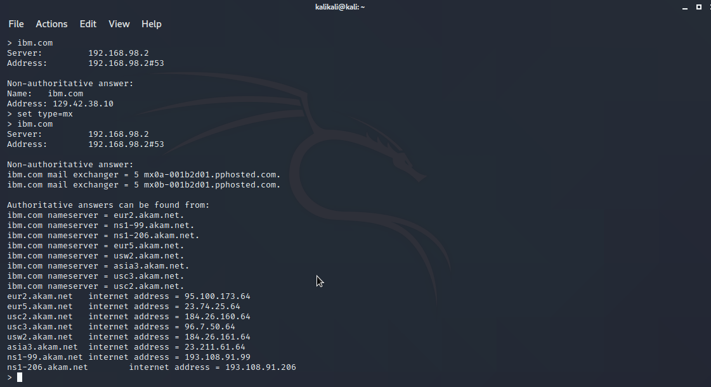

1. Wipro.com

* First open kali linux terminal
* Run as administrator by usin sudo su –
* Enter password
* After entering in to the root directory and go with the following commands

1. nslookup
2. set type=mx
3. Wipro.com

* You will get all the info about the mail servers

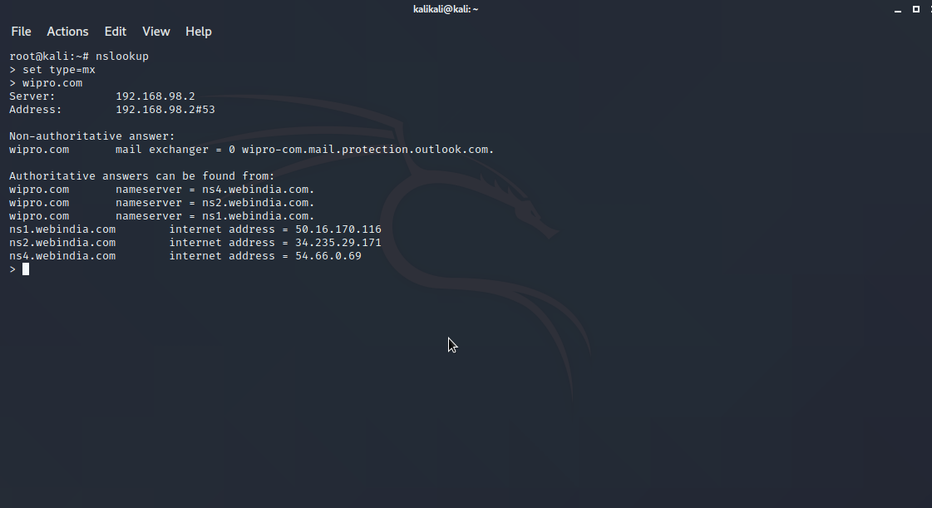

1. Scan and find out port numbers open 203.163.246.23

* First, open terminal in kali linux.
* Type following commands:

1. nmap 203.163.246.23 or nmap –F 203.163.246.23 (to scan only open ports / to scan faster)

* Scan progress starts and will get the result

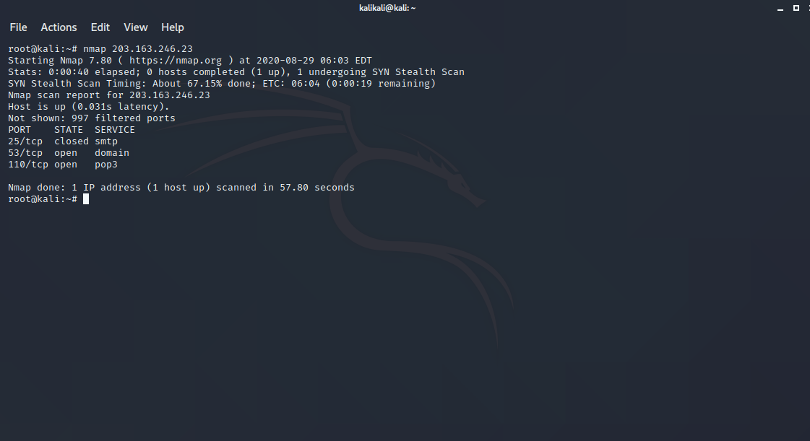

1. Install Nessus in VM and scan laptop or desktop for CVE

* Go to Nessus essentials from chrom through virtual machine
* Select Nessus for the respective plattform(windows/linux etc)
* Give essential details and download it from the [https://www.tenable.com/products/nessus essentials/](https://www.tenable.com/products/nessus%20essentials/)
* After installation access it with localhost< ****>
* Allow acess to the webpage
* Click on New Scan and go for advanced scan.
* Give the file name and target IP with optional discription in settings
* In credentials select Windows, Give User name and password
* Launch the application for scan.

